TASK 6

Three phase motor connected to full voltage magnetic starter controlled by step forward and reverse push button with indicating light stop forward and reverse

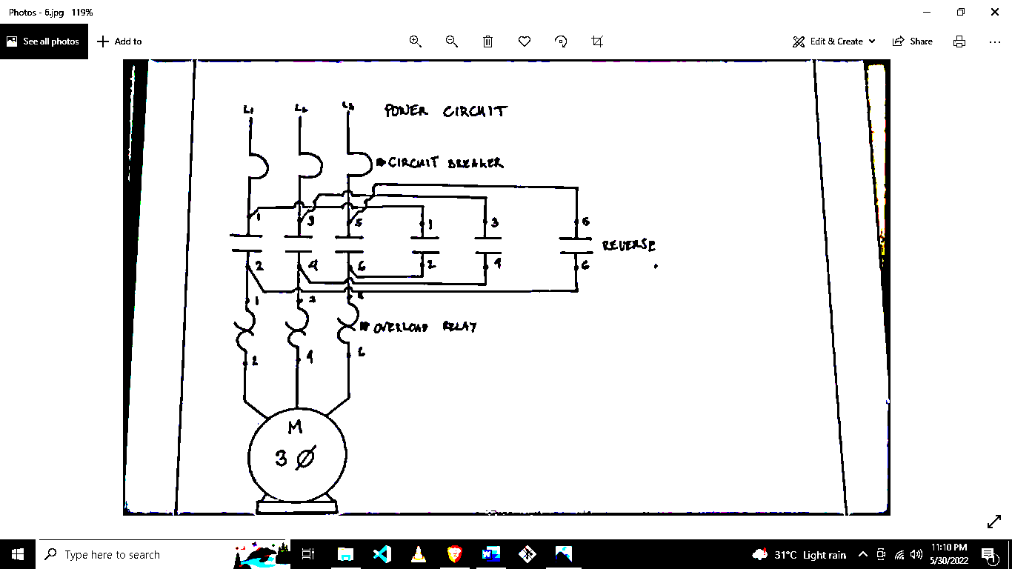

Instructor

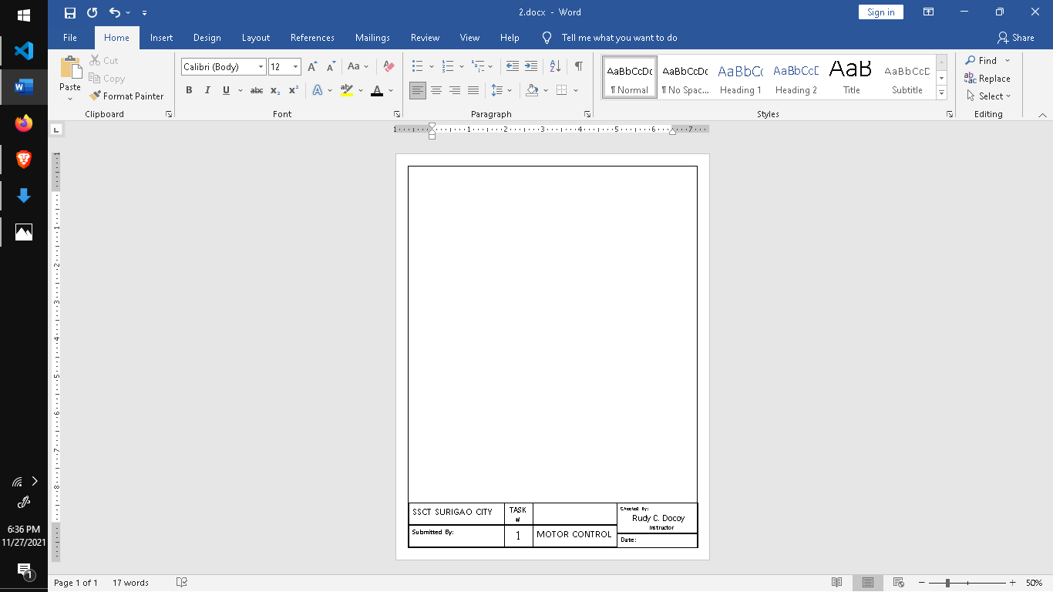



Checked By:

Rudy C. Docoy

MOTOR CONTROL

**Date :**May 31, 2022



TASK #

6

SSCT SURIGAO CITY

BEET 3C

Submitted By:

